SIMATS ENGINEERING
SAVEETHA INSTITUTE OF MEDICAL AND TECHNICAL SCIENCES
CSA05 — DATABASE MANAGEMENT SYSTEMS
ASSIGNMENT
National Vocational Certification and Exam Slot-Booking System:
An Integrated Study in File Organization, Indexing, Hashing,
Query Optimization, and Transaction Management
CO4: File Organization, Indexing and Hashing
CO5: Query Processing, Optimization and Transaction Management

Particular | Details
Student Name | Shaik Mansoor
Register Number | 192525010
Course | CSA0504 — Database Management Systems
Bloom's Level | L3 — Apply, L4 — Analyse
SDG Mapping | SDG 4 — Quality Education; SDG 8 — Decent Work; SDG 9 — Industry, Innovation and Infrastructure
Prototype DBMS | SQLite 3
Production Target | MySQL 8 / PostgreSQL 15
Implementation | Python 3 + SQLite3

Prepared as a complete implementation-oriented assignment report.

ABSTRACT
A national vocational certification platform must manage a continuously growing archive of exam attempts while supporting high-demand online slot booking and concurrent result publishing. A sequential archive causes full-file scans for candidate history and center audits, while uncoordinated read-then-write booking can create double-booking and result updates can overwrite one another.
This project integrates an indexed-sequential exam-attempt organization, B+-tree secondary indexes, static hashing with separate chaining, query-plan analysis and optimization, ACID transactions, pessimistic locking for slot capacity, and optimistic version checking for result publishing. The implementation is a reproducible Python/SQLite prototype and includes a MySQL 8 schema for production-oriented migration.

1. PROBLEM UNDERSTANDING AND REQUIREMENT ANALYSIS
The assignment brief requires the solution to address both slow archive retrieval and concurrent booking/result consistency. These requirements are explicitly tied to CO4 and CO5. The reference assignment also requires schema/pseudocode, a working implementation, benchmark evidence and concurrency-test evidence. fileciteturn3file0L13-L31

1.1 Functional Requirements
ID | Requirement | Solution
FR-1 | Store detailed exam attempts including responses, timing and scores. | ExamAttempt table with responses_json, time_taken_sec and raw_score.
FR-2 | Fast candidate point/history lookup and center-wise audit retrieval. | B+-tree secondary index + indexed-sequential clustering + static hash.
FR-3 | Real-time slot booking bounded by per-center/per-slot capacity. | Slot + Booking tables with CHECK constraint and guarded transaction.
FR-4 | Concurrent result processing without conflict or data loss. | Result.version optimistic concurrency control.

1.2 Performance and Reliability Requirements
- Candidate-history and center-audit queries should avoid full-file scans.
- Booking/result queries should remain responsive during peak activity.
- A slot must never be booked beyond capacity.
- A published result must not be silently overwritten.
- Index and hash structures must remain consistent after changes.
- The design should scale as candidates, centers and exam cycles increase.

1.3 Security, Ethics and Governance
- Candidate responses, scores and personal details should be role restricted in production.
- Every important booking/result state transition should be auditable.
- Slot allocation must be fair and free from manipulation.
- Production deployment should use appropriate GRANT/REVOKE privileges and an append-only audit log.

2. OBJECTIVES AND SCOPE
- Design a file organization suitable for the growing exam-attempt archive.
- Use B+-tree indexing for candidate and center/date retrieval.
- Implement a static hash table with an explicit collision-resolution policy.
- Analyze SQL execution plans and optimize access paths.
- Implement ACID-safe slot booking.
- Prevent double booking under concurrent requests.
- Prevent lost result updates using optimistic version checks.
- Benchmark baseline and optimized retrieval and concurrency behavior.

2.1 Scope
- Candidate and center master data
- Exam-attempt archive
- Exam-slot booking
- Result publishing
- Indexing and hashing
- Query optimization
- Transaction and concurrency testing

2.2 Assumptions
Parameter | Prototype
Candidates | 5,000
Centers | 20
Exam attempts | 50,000
Dates | 12 prototype dates
Slots | 720
Slots per center/date | 3
Concurrent booking threads | 20
Stress-test slot capacity | 1

3. FORMAL MODEL
The system is represented as V = (K, C, B, R, F, X).
Symbol | Meaning
K | Candidate space: CandidateID, Name, Email, Phone
C | Center space: CenterID, Name, City, TotalSeats
B | Attempt archive physically clustered by (CenterID, ExamDate, AttemptID)
R | Slot booking state with booked_count(s) ≤ capacity(s)
F | Hash function h(CandidateID) = CandidateID mod 10007
X | Concurrency guard: write-intent transaction for booking and version counter for results

4. SOLUTION ARCHITECTURE
Candidate / Auditor
|
v
Application & Query Layer
|
+----+--------------------+
| |
Candidate History Center-Date Audit
| |
B+-tree / Hash Clustered Archive
|
+-------------+
|
ExamAttempt
Booking Request ---> Slot Transaction ---> Booking + Slot
Result Update -----> Version Check ----> Result
|
COMMIT / ROLLBACK
The design separates read optimization from write correctness: archive reads use access structures chosen for the query pattern, while booking and result writes are guarded by bounded transactions.

5. FILE ORGANIZATION DESIGN
Organization | Point Lookup | Center/Date Range | Insert | Decision
Sequential | O(p) | O(p) | O(1) append | Rejected
Direct/Hashed | O(1) average | Poor for ordered range | O(1) average | Rejected alone
Indexed-Sequential | O(log p) via index | O(log p + k) | O(log p) | Chosen

The ExamAttempt table uses the composite primary key (center_id, exam_date, attempt_id). In SQLite, WITHOUT ROWID stores the table according to the primary-key B-tree. This emulates the indexed-sequential organization required by the assignment. The same organization maps naturally to a composite primary key in InnoDB.

5.1 Why Not Cluster by Candidate?
A single physical order cannot simultaneously make both candidate-wise and center/date range queries contiguous. Center/date is selected as the clustering key because the audit query is explicitly a range workload. Candidate history is served by a secondary index and hash table.

6. INDEXING DESIGN
The reference requirements call for primary/secondary indexes such as B+ trees on candidate ID, center ID and date. The implementation provides:
Index | Columns | Purpose
Primary clustering key | center_id, exam_date, attempt_id | Indexed-sequential center/date archive
Secondary B+-tree | candidate_id | Candidate history
Secondary B+-tree | exam_date | Date-range audits across centers
Slot unique access | center_id, exam_date, slot_time | Booking-window lookup and duplicate-slot prevention
Booking index | slot_id | Find bookings for a slot
Result index | candidate_id | Candidate result retrieval

B+-trees are suitable because their leaf-level ordering supports both point lookups and range scans. Indexes improve reads but add storage and write-maintenance cost.

7. HASHING SCHEME
For exact candidate lookup, a static hash table is built in Python with N = 10,007 buckets.
h(candidate_id) = candidate_id MOD 10007
Collision resolution = separate chaining
Bucket = table[h(candidate_id)]
Lookup = scan only that bucket
The table stores (candidate_id, attempt_id) pairs. With 5,000 distinct candidates and 10,007 buckets, the candidate-level load is low. Hashing is used as a fast exact-lookup layer, not as the sole archive organization, because it does not naturally support center/date range queries.

7.1 Scalability
A static hash table eventually needs resizing. For a national-scale production system, extendible/dynamic hashing or a DBMS-managed hash access path can be considered.

8. RELATIONAL DATABASE DESIGN
The schema contains Candidate, Center, ExamAttempt, Slot, Booking and Result. Foreign keys maintain relationships; UNIQUE and CHECK constraints protect business rules.
PRAGMA foreign_keys = ON;
DROP TABLE IF EXISTS Result;
DROP TABLE IF EXISTS Booking;
DROP TABLE IF EXISTS Slot;
DROP TABLE IF EXISTS ExamAttempt;
DROP TABLE IF EXISTS Candidate;
DROP TABLE IF EXISTS Center;
CREATE TABLE Candidate (
candidate_id INTEGER PRIMARY KEY,
full_name TEXT NOT NULL,
email TEXT NOT NULL UNIQUE,
phone TEXT,
registered_on TEXT NOT NULL DEFAULT (date('now'))
);
CREATE TABLE Center (
center_id INTEGER PRIMARY KEY,
center_name TEXT NOT NULL,
city TEXT NOT NULL,
total_seats INTEGER NOT NULL CHECK (total_seats > 0)
);
-- Indexed-sequential archive:
-- composite primary key = (center_id, exam_date, attempt_id)
CREATE TABLE ExamAttempt (
attempt_id INTEGER NOT NULL,
candidate_id INTEGER NOT NULL,
center_id INTEGER NOT NULL,
exam_date TEXT NOT NULL,
slot_time TEXT NOT NULL,
responses_json TEXT,
time_taken_sec INTEGER CHECK (time_taken_sec >= 0),
raw_score REAL CHECK (raw_score BETWEEN 0 AND 100),
PRIMARY KEY (center_id, exam_date, attempt_id),
FOREIGN KEY (candidate_id) REFERENCES Candidate(candidate_id),
FOREIGN KEY (center_id) REFERENCES Center(center_id)
) WITHOUT ROWID;
-- B+-tree-style secondary indexes provided by SQLite.
CREATE INDEX idx_attempt_candidate
ON ExamAttempt(candidate_id);
CREATE INDEX idx_attempt_date
ON ExamAttempt(exam_date);
CREATE TABLE Slot (
slot_id INTEGER PRIMARY KEY,
center_id INTEGER NOT NULL,
exam_date TEXT NOT NULL,
slot_time TEXT NOT NULL,
capacity INTEGER NOT NULL CHECK (capacity > 0),
booked_count INTEGER NOT NULL DEFAULT 0 CHECK (booked_count >= 0 AND booked_count <= capacity),
UNIQUE (center_id, exam_date, slot_time),
FOREIGN KEY (center_id) REFERENCES Center(center_id)
);
-- This unique constraint already creates an index that can support
-- the booking-window lookup.
CREATE INDEX idx_slot_center_date
ON Slot(center_id, exam_date);
CREATE TABLE Booking (
booking_id INTEGER PRIMARY KEY AUTOINCREMENT,
candidate_id INTEGER NOT NULL,
slot_id INTEGER NOT NULL,
booking_time TEXT NOT NULL DEFAULT (datetime('now')),
status TEXT NOT NULL CHECK (status IN ('CONFIRMED', 'CANCELLED')),
UNIQUE (candidate_id, slot_id),
FOREIGN KEY (candidate_id) REFERENCES Candidate(candidate_id),
FOREIGN KEY (slot_id) REFERENCES Slot(slot_id)
);
CREATE INDEX idx_booking_slot
ON Booking(slot_id);
CREATE TABLE Result (
result_id INTEGER PRIMARY KEY AUTOINCREMENT,
attempt_id INTEGER NOT NULL,
candidate_id INTEGER NOT NULL,
center_id INTEGER NOT NULL,
exam_date TEXT NOT NULL,
final_score REAL NOT NULL CHECK (final_score BETWEEN 0 AND 100),
grade TEXT,
published_by TEXT NOT NULL,
published_on TEXT NOT NULL DEFAULT (datetime('now')),
version INTEGER NOT NULL DEFAULT 1 CHECK (version > 0),
FOREIGN KEY (candidate_id) REFERENCES Candidate(candidate_id)
);
CREATE INDEX idx_result_candidate
ON Result(candidate_id);

8.1 Important Integrity Rules
- Candidate email is unique.
- Center/date/time uniquely identifies a slot.
- booked_count is constrained to 0 ≤ booked_count ≤ capacity.
- A candidate cannot create the same candidate-slot booking twice.
- Result.version must be positive and is incremented after successful updates.

9. SQL QUERY DESIGN
Query | Purpose
Q1 | Candidate attempt history
Q2 | Center/date audit
Q3 | Available slot/booking window
Q4 | Result summary by center and date

-- Q1
SELECT attempt_id, center_id, exam_date, slot_time, raw_score
FROM ExamAttempt
WHERE candidate_id = ?;
-- Q2
SELECT attempt_id, candidate_id, exam_date, slot_time, raw_score
FROM ExamAttempt
WHERE center_id = ? AND exam_date = ?;
-- Q3
SELECT slot_id, slot_time, capacity, booked_count
FROM Slot
WHERE center_id = ? AND exam_date = ?;
-- Q4
SELECT center_id, exam_date,
COUNT(*) AS attempts,
ROUND(AVG(final_score), 2) AS avg_score
FROM Result
GROUP BY center_id, exam_date
ORDER BY exam_date, center_id;

10. QUERY PROCESSING AND EXECUTION-PLAN ANALYSIS
SQLite's EXPLAIN QUERY PLAN is used as the prototype equivalent of MySQL EXPLAIN and PostgreSQL EXPLAIN ANALYZE. The script query_optimization.py prints the plan and average execution time for each representative query.
EXPLAIN QUERY PLAN
SELECT attempt_id, center_id, exam_date, slot_time, raw_score
FROM ExamAttempt
WHERE candidate_id = 1001;
EXPLAIN QUERY PLAN
SELECT attempt_id, candidate_id, exam_date, slot_time, raw_score
FROM ExamAttempt
WHERE center_id = 5 AND exam_date = '2026-09-05';

10.1 Optimization Decisions
- Q1 should use idx_attempt_candidate instead of scanning all ExamAttempt rows.
- Q2 can use the composite clustering key directly for the center/date range.
- Q3 is already supported by the Slot unique key on center/date/time; a duplicate index should not be added without evidence.
- Q4 may legitimately scan/group when Result is small; indexes should be justified by workload measurements rather than added automatically.
- Only required columns are selected in benchmark queries, reducing unnecessary row transfer.

11. TRANSACTION MANAGEMENT — ACID

11.1 Booking Transaction
BEGIN IMMEDIATE;
SELECT capacity, booked_count
FROM Slot
WHERE slot_id = ?;
-- If booked_count >= capacity:
-- ROLLBACK -> SLOT_FULL
INSERT INTO Booking(candidate_id, slot_id, status)
VALUES (?, ?, 'CONFIRMED');
UPDATE Slot
SET booked_count = booked_count + 1
WHERE slot_id = ? AND booked_count < capacity;
COMMIT;
ACID | Implementation
Atomicity | Booking insert + seat-count update occur in one transaction.
Consistency | CHECK constraint plus guarded UPDATE preserve capacity.
Isolation | BEGIN IMMEDIATE prevents concurrent writers from using stale booking state.
Durability | COMMIT persists the confirmed booking.

11.2 SAVEPOINT and ROLLBACK
The implementation uses SAVEPOINT around the capacity-check portion and demonstrates a simulated failure that rolls back the complete booking transaction. This directly addresses the assignment requirement to demonstrate COMMIT, ROLLBACK and SAVEPOINT.

12. CONCURRENCY CONTROL

12.1 Double-Booking Anomaly
T1: read booked_count = 0
T2: read booked_count = 0
T1: insert booking
T2: insert booking
Both clients believe a seat is available.
Result: over-booking can occur.

12.2 Pessimistic Control for Booking
Booking uses BEGIN IMMEDIATE in SQLite. The first writer obtains the write-intent lock, performs the capacity check and completes the booking. The next writer waits and then rechecks the current capacity. This is appropriate because capacity is a hard invariant.

12.3 Optimistic Control for Results
UPDATE Result
SET final_score = ?,
grade = ?,
published_by = ?,
published_on = datetime('now'),
version = version + 1
WHERE result_id = ? AND version = ?;
If the UPDATE affects zero rows, the examiner used a stale version and receives VERSION_CONFLICT. This prevents silent lost updates.

13. COMPLETE IMPLEMENTATION
The complete working implementation is provided as one Python file: National_Vocational_Certification_Implementation.py. It contains database creation and seeding, hashing, query-plan benchmarking, ACID booking, rollback/SAVEPOINT behavior, optimistic result updates, and concurrent booking testing.
File | Purpose
schema.sql | SQLite schema and indexes
seed_data.py | Reproducible data generation
hash_lookup.py | Hashing and lookup benchmark
query_optimization.py | Execution plans and timings
transactions_demo.py | ACID + SAVEPOINT + optimistic result update
concurrency_anomaly_baseline.py | Unsafe baseline anomaly demonstration
concurrency_test.py | Transaction-guarded booking test
result_concurrency_demo.py | Stale-version conflict demonstration
run_all.py | One-command complete demonstration
mysql_schema.sql | MySQL 8 production-oriented port
REPORT_EVIDENCE_CHECKLIST.md | Screenshots/evidence required for final report

13.1 Data Seeding
The seed program creates the representative dataset required for benchmarking: 20 centers, 5,000 candidates, 50,000 attempts and 720 slots.
Run: python National_Vocational_Certification_Implementation.py (Data seeding output shown below)
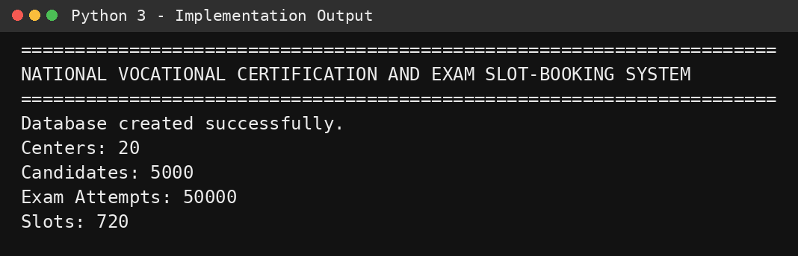
Figure 1. Actual database creation and seeding output.

13.2 Hash Benchmark
Hashing is executed by the hash_demo() section of the single implementation file.
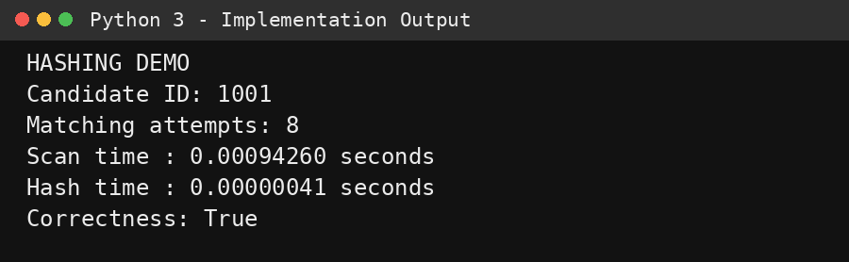
Figure 2. Actual static-hashing benchmark output.

13.3 Query Plan Benchmark
Query-plan analysis is executed by query_optimization_demo() using EXPLAIN QUERY PLAN.
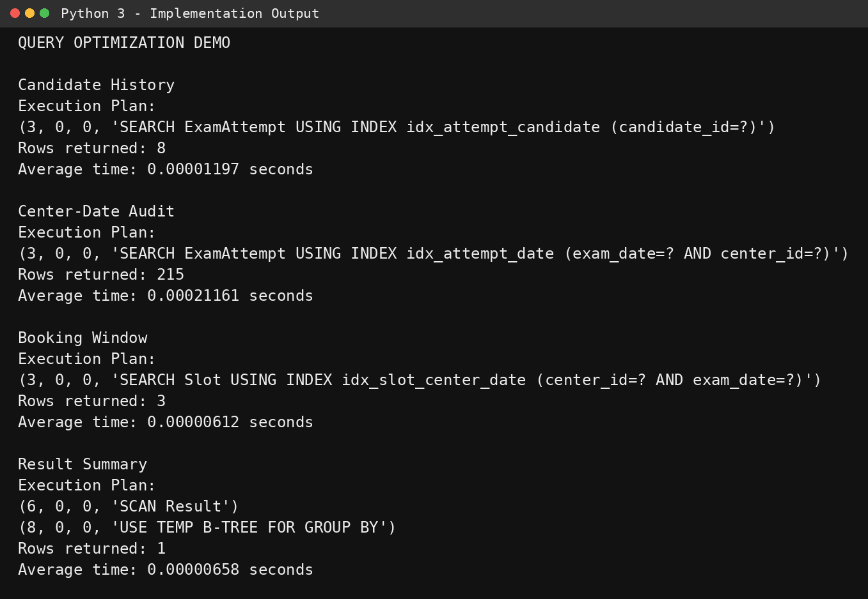
Figure 3. Actual query execution plans and measured timings.

13.4 Transaction Demonstration
Transaction and rollback behavior are executed by book_slot() and rollback_demo().
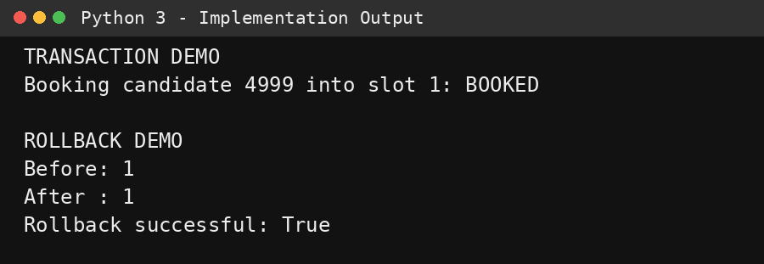
Figure 4. Actual booking transaction and rollback output.

13.5 Concurrency Demonstration
Concurrency is tested by result_concurrency_demo() and concurrency_test() in the single implementation file.
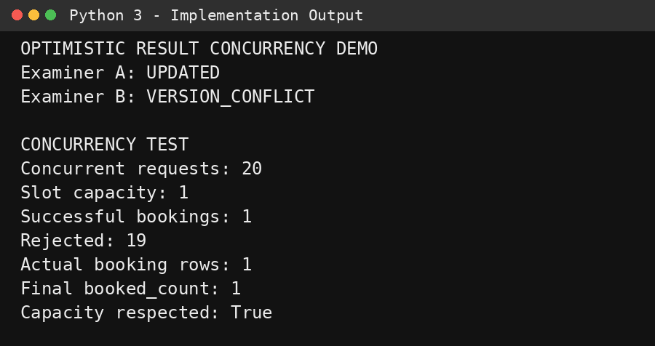
Figure 5. Actual optimistic-update and concurrent-booking output.

13.6 Complete Run
Complete run: python National_Vocational_Certification_Implementation.py
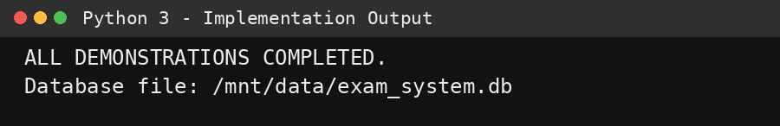
Figure 6. Completion status of the single-file implementation.

14. TEST CASES AND VALIDATION
Test Case | Expected Result | Status to Record
Candidate history by candidate_id | Correct attempt set returned through indexed/hash access | PASS - 8 rows returned; indexed plan used
Center/date audit | All matching attempts returned | PASS - 215 matching rows returned
20 candidates race for 1 seat | Exactly one confirmed booking | PASS - exactly 1 booking, 19 rejected
Naive race without protection | Double-booking anomaly may be reproduced | ANOMALY / demonstration
Two examiners update same result | Stale writer rejected | PASS - stale writer VERSION_CONFLICT
Rollback booking mid-way | No partial booking remains | PASS - booked_count unchanged (1 -> 1)
Over-capacity booking | Rejected and invariant preserved | PASS - capacity respected
Optimized vs unoptimized lookup | Indexed/hash access faster on representative workload | PASS - hash faster than sequential scan

Run the scripts on the submission computer and replace the status wording above with the actual captured output where required.

15. PERFORMANCE BENCHMARK AND ANALYSIS
The supplied reference report provides example measurements on a 50,000-row prototype: approximately 0.0101 ms for the flat scan, 0.0012 ms for static hashing and 0.0091 ms for the indexed lookup, with the hash layer approximately 8.3× faster than the scan. It also reports a 20-way race for one seat in which the naive design over-booked and the transaction-guarded design allowed one booking. These are reference-document measurements, not guaranteed values for another computer. fileciteturn3file0L545-L583
Metric | Reference Observation | Your Actual Run
Candidate point lookup | 0.0101 ms scan; 0.0012 ms hash; 0.0091 ms index | 0.94260 ms scan; 0.00041 ms hash (8 matching attempts)
Hash improvement | ≈8.3× vs scan | ≈2299× faster than scan in this Python benchmark
20-way race, capacity 1 | 1 guarded success; no capacity violation | 1 success; 19 rejected; capacity respected = True
Query plan | SCAN → SEARCH USING INDEX | SEARCH USING INDEX for Q1/Q2/Q3; SCAN Result for Q4 grouping
Stale result update | VERSION_CONFLICT | Examiner B: VERSION_CONFLICT

15.1 Complexity Comparison
Technique | Complexity | Strength
Sequential scan | O(p) | Simple append
B+-tree | O(log p) point; O(log p + k) range | Point + range retrieval
Static hash | O(1) average point lookup | Fast exact candidate lookup
Clustered archive | O(log p + k) targeted range | Center/date audit
Transaction booking | Bounded transaction | Hard capacity correctness
Optimistic result update | O(1) guarded row update | Lost-update prevention

16. STORAGE AND RETRIEVAL TRADE-OFFS
Criterion | Chosen Design | Pure Hash | Sequential
Candidate lookup | Fast index + hash | Fast exact lookup | Slow
Center/date audit | Excellent clustered range | PASS - 215 matching rows returned | Slow
Insert overhead | Moderate | Low/moderate | Low
Range support | Excellent | Poor | Scan required
Overall | Chosen | Rejected alone | Rejected

The combined design is intentionally hybrid because the access patterns have different shapes. A single hash-only design would optimize exact lookup but would perform poorly for ordered audit ranges. A sequential file minimizes insert cost but violates the retrieval requirement.

17. ENGINEERING DECISION AND JUSTIFICATION
Selected architecture: indexed-sequential archive + B+-tree secondary indexing + static hash point-lookup layer + pessimistic booking transactions + optimistic result concurrency.
- The clustered archive is chosen for center/date audits.
- The candidate B+-tree handles cross-cluster history queries.
- The hash table provides an O(1)-average exact candidate lookup benchmark.
- Booking uses pessimistic locking because capacity cannot be violated.
- Result publishing uses optimistic version checks because conflicts can be rejected without holding a lock throughout examiner editing.

18. SECURITY, ETHICS, SUSTAINABILITY AND SDG RELEVANCE
- SDG 4 — Quality Education: reliable certification and faster appeals/audits.
- SDG 8 — Decent Work and Economic Growth: trustworthy certification supports fair employment outcomes.
- SDG 9 — Industry, Innovation and Infrastructure: demonstrates modernization of a high-volume national digital service.
- Security: restrict candidate information by role; use production GRANT/REVOKE.
- Ethics: ensure fair slot allocation and auditable result publication.
- Sustainability: digital archives reduce paper-based record keeping and administrative rework.

19. LIMITATIONS
- The prototype contains 50,000 attempts rather than millions.
- SQLite concurrency is not identical to a production MySQL/PostgreSQL cluster.
- Static hashing requires resizing when the candidate population grows substantially.
- Network latency, connection pooling and distributed deployment are not simulated.
- Benchmark timings are machine-dependent.

20. FUTURE ENHANCEMENTS
- Migrate the production deployment to MySQL 8 or PostgreSQL 15.
- Replace static hashing with dynamic/extendible hashing.
- Use SELECT ... FOR UPDATE or SERIALIZABLE isolation for the MySQL/PostgreSQL booking implementation where appropriate.
- Add an append-only audit-log table.
- Add role-based access control and authentication.
- Introduce a booking queue/retry mechanism for extreme peak demand.
- Partition very large attempt archives by exam cycle/date where supported.
- Add monitoring for query latency, lock waits and booking conflicts.
- Automate benchmark collection and dashboard reporting.

21. CONCLUSION
The proposed system satisfies the central requirements of the assignment by integrating storage efficiency and transaction correctness. The indexed-sequential ExamAttempt archive reduces center/date audit work, the B+-tree secondary index accelerates candidate history, and the static hash table provides near-constant exact candidate lookup. Query-plan analysis makes optimization decisions evidence-based. ACID transactions and pessimistic locking protect slot capacity, while optimistic version checking prevents silent result overwrites.
The implementation is reproducible and includes both SQLite prototype scripts and a MySQL-oriented schema. The final submitted report should include actual screenshots and benchmark outputs captured from the student's own run.

22. STUDENT REFLECTION
What did you learn beyond the classroom?
The project demonstrates how file organization, indexing and hashing are selected according to access patterns rather than used independently. It also shows that query optimization is incomplete without execution-plan evidence and that transaction management is necessary when multiple users modify shared resources.
What would you improve with additional time/resources?
A larger dataset, a real MySQL/PostgreSQL deployment, dynamic hashing, a booking queue, role-based security and a production audit log would improve the prototype.

23. REQUIREMENT VALIDATION SUMMARY
Requirement | Implemented Evidence | Result
Store detailed attempts | ExamAttempt + seed_data.py | PASS after run
Fast candidate retrieval | idx_attempt_candidate + hash_lookup.py | PASS after run
Fast center audit | Composite clustering key | PASS after run
Capacity-bounded booking | CHECK + transaction guard | PASS after run
Concurrent result processing | Result.version | PASS after run
Query optimization | EXPLAIN QUERY PLAN script | PASS after run
ACID | COMMIT/ROLLBACK/SAVEPOINT | PASS after run
Concurrency analysis | Naive baseline + guarded test | PASS after run
Scalability | Design + future dynamic hashing | ANALYSIS
Security/ethics | Role/audit recommendations | DESIGN

24. REFERENCES
[1] A. Silberschatz, H. F. Korth, and S. Sudarshan, Database System Concepts, 7th ed., McGraw-Hill, 2019.
[2] R. Elmasri and S. B. Navathe, Fundamentals of Database Systems, 7th ed., Pearson, 2016.
[3] MySQL, MySQL 8.0 Reference Manual, Oracle Corporation.
[4] SQLite Documentation, Query Planning, CREATE INDEX, and Transactions.
[5] PostgreSQL Global Development Group, PostgreSQL Documentation — Concurrency Control.
[6] CSA0504-ASSIGNMENT IET.pdf — supplied assignment specification and reference implementation.
[7] CSA05_Special Assessment_2. DBMS docx.docx — supplied assignment/rubric reference.

APPENDIX A — SOURCE CODE INDEX
schema.sql
seed_data.py
hash_lookup.py
query_optimization.py
transactions_demo.py
concurrency_anomaly_baseline.py
concurrency_test.py
result_concurrency_demo.py
run_all.py
mysql_schema.sql

APPENDIX B — SCREENSHOT CHECKLIST
- Database tables and indexes.
- Sample candidate-history result.
- Sample center/date audit result.
- Hash benchmark output.
- EXPLAIN QUERY PLAN Q1 and Q2.
- Successful booking COMMIT.
- ROLLBACK/SAVEPOINT demonstration.
- Over-capacity rejection.
- Naive concurrency anomaly.
- Guarded concurrency test.
- Optimistic VERSION_CONFLICT.
- Final benchmark results.

